**1.PROBLEM**

**CSS Image with saturation**

Shiyas is very much passionate about photography. The Times Of India organized a "Foto Contest" to identify the best click captured by young talents in the country with a cash reward of about 50,000.  
  
On hearing this, Shiyas immediately registered himself for the contest and started taking a variety of photos. He took a lot of photos, but selected one among them for the contest for editing. Now, he is in need of your help in the editing process to upload his picture in the contest. Hence create a web page to produce the saturation effect using filter property in CSS.

**Hints :**

**filter property**

The filter property defines visual effects (like blur and saturation) to an element (often <img>).

**saturate**

0% (0) will make the image completely un-saturated. 100% is default and represents the original image. Values over 100% provides super-saturated results.

Syntax :

filter: none | blur( ) | brightness( ) | contrast( ) | drop-shadow( ) | grayscale( ) | hue-rotate( ) | invert( ) | opacity( ) | saturate( ) | sepia( ) | url( );

**Content :**  
h1 - Wedding Album  
img src - weddingAlbum.jpg  
style - 'filter:saturate(2)'  
  
**Constraints :**

**h1**should be present inside the **center** tag  
The count of **img**tag in should be 2.  
The first img tag  - original image.  
The second img tag - image with effects.  
Inline style should be applied with given filter properties.  
  
**Note :**  
Web page should be displayed as shown in the screenshot.  
Kindly refer the content which is given as a part of the description  
  
**Sample Screenshot 1:**  
  
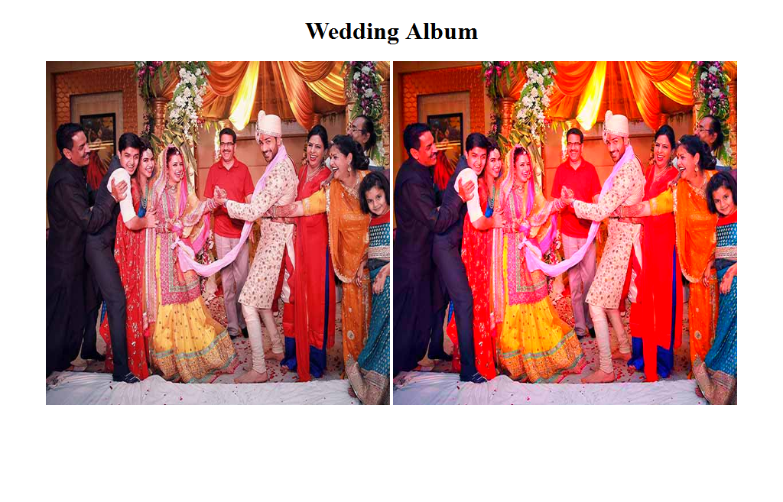  
  
**Sample Screenshot 2:**  
  
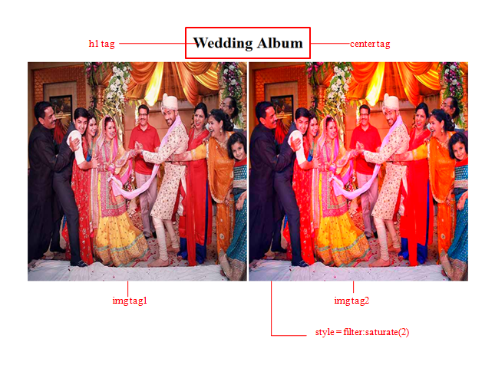

**2.PROBLEM**

**CSS - Responsive Image**

Tulips Photography Services specialize in wedding photography, corporate events, often traveling to your destination to capture the perfect moments in the perfect place. Sakshi is the person in charge for the company's website maintenance and customer interactions in the web page. Her team members regularly update the Newsfeed, share their recent captures, respond to feedbacks, confirm orders, etc on the websites. Recently, Sakshi got a feedback from a customer that the images uploaded in the site suddenly could not be scaled up properly with good image quality. This problem has to be corrected quickly because it would spoil the company's reputation.  
Sakshi wanted to know the usage of the width property in CSS which will make the image responsive. Create a web page to help her understand the usage of the width property in CSS.

**Hints :**

**responsive image**

If the width property is set to 100%, the image will be responsive and scale up and down

Syntax :

for eg:

<style>

img {

max-width: 100%;

height: auto; }

</style>

**Content :**  
h1 - Responsive Image

img - Wedding.jpg

class attribute value for img - **image1**

**max - width** property value should be **100%**

**height** value should be **auto**  
  
**Constraints :**  
**'img'**tag should be used to design the web page.

Given styling properties should be used as an internal style  
For making the image responsive, styles must be applied to the img tag by using its class attribute.  
  
**Note :**  
Web page should be displayed as shown in the screenshot.  
Kindly refer the content which is given as a part of the description  
  
**Sample Screenshot 1:**  
  
The size of the image is responsive to the browser size.  
  
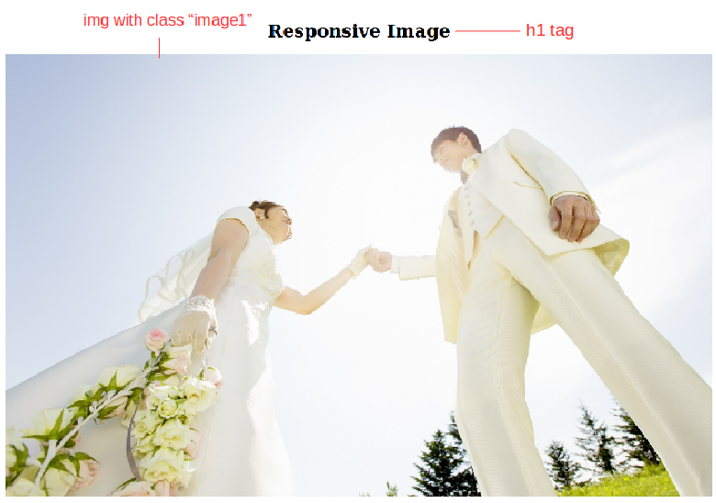

**3.PROBLEM**

**Media Types - audio control**

"Pink Frag Event Organizers" has been providing outstanding services in hosting and managing Events in the city. The official website for the company is created and maintained by "Ivory creaters". As technology is changing, the website has to be updated based on the change. Also the entire content in textual language has become a boredom job for the designers.    
  
Hence, the creative team has assigned you to change the theoretical contents into audio clip and include it on the webpage by using the audio tag for ensuring user convenience.

**Hints :**

**audio tag**

The HTML <audio> element is used to embed sound content in documents. It may contain one or more audio sources, represented using the src attribute or the <source> element.

**control attribute**

The controls attribute adds audio controls, like play, pause, and volume. The <source> element allows you to specify alternative audio files which the browser may choose from.

The browser will use the first recognized format.

Syntax :

<audio controls>

 <source src="xxx.ogg" type="audio/ogg">

 <source src="xxx.mp3" type="audio/mpeg">

</audio>

**Content :**  
h1 - Audio Tag  
div - Pink Frag Event is a reputed organization, which has come into being in 2009, as a Sole Proprietorship Firm, with a sole aim of achieving  
the trust and support of large customers. We have indulged our all endeavors towards offering trustworthy Wedding Event Management, Promotional  
Event Management, Birthday Party Management and many more. All our services are reliable and offered keeping the exact customers’ preferences  
and choice in mind. To offer these services, we have hired specialized professionals, who are capable of understanding as well as accomplishing  
the specific customers’ desires. We have adopted modern technology, to cope up with the challenges of industry. We keep all quality parameters  
in mind, so that we cannot make any compromise in terms of the excellence of products.  
div - A sample audio for background music of the event is provided below.  
audio tag.  
  
**Constraints :**  
The file name must be index.html  
Refer the screenshot for html specifications  
The source attribute must be present in the same order as mentioned in the hint.  
**Note :**  
The web page should be displayed as shown in the screenshot.  
Kindly refer the content which is given as a part of description.  
The audio file is given as a part of template.  
  
**Sample Screenshot 1 :   
  
